**PUSL3119 Computing Individual Project**

**Project Initiation Document (PID)**

Network Management System

Supervisor: Mr. Chamara Dissanayake

Name: Galappaththi Madubhashitha

Plymouth Index Number: 10749058

Degree Program: BSc(Hons) Computer Network

**Introduction**

The network engineers of most companies looking for some kind of smooth and user friendly networking tools for their day-to-day works. So we know there are different kind of networking tools are in the industry. But the problem is those are not open source tools and need to spent money to buy and work on them. And the other purpose of my problem statement is that there are less number of tools to gather physical locations of networking devices but the thing also those are not open source and difficult to use. So here am going to create a Networking Management System, some networking tools to ping network devices and monitoring them, gather the physical location by searching IP address, a tool to execute network troubleshooting by using this network management system and I hope to develop a tool to do some small configurations of network devices. So it is a complex of different kind of small networking tools. In this case am going to mainly focus on ping monitoring tool, the location detecting tool, troubleshooting tool and I hope to do other tools as my furthermore developments.

In here this Network Management System is totally depends on Network Automations by using Python programming language. So this is a Python application. I using Python because as a language, Python is easy to do network automation parts. I am developing this application for only PC because you know its hard to manage networking devices by using a Mobile.

**Business Case**

* Business need -: The main business need of this project is to work with an easy-going network management system.

Ex. I went for job in June of 2022 as a networking assistant. It was a small IT solution company, the first day of that job I went to a site, in there my networking team have already launched a network with CCTV cameras. And they were about to configure the cameras but they didn’t know the exact physical location of those cameras that they launched, and what was the exact switch port that cameras were connected. In that case they didn’t have an open-source network device’s physical location detecting tool. So when I was about to find what am going to do with my final year project, I remembered that CCTV camera case and its came as an idea with I should create an open source network device’s physical location detecting tool.

Like above example, not only location detecting tool but also all the small tools that I am going to create are very helpful and easy to work even with a tough networking environment.

* Business objectives -: Its totally free, smooth and all the tools are easy to execute. So even a large network can easily manageable. And reducing man-made errors, time consumption, network vulnerabilities and also making secure networking environment.

**Project Objectives**

* Logging page to create an account or sign into an existing account.
* Dashboard to select which tool that users are going to execute.
* By clicking on the ping monitoring tool button, users can ping the network by using the management system.
* By clicking on the location detecting tool button, users can find the physical locations of particular network devices by using this network management system.
* By clicking on the troubleshooting tool button, users can do the network troubleshooting by the system, without going into the CMD or terminals.
* By clicking on the network configuration tool button, users can do the network devices’ configurations by the system.

Technologies

* I need to use python interfaces technologies to execute all the interfaces of the system especially to this logging page. Python exception handling technology for the user logging credentials.
* buttons, dashboard technology, some kind of python GUI technologies.
* Python libraries, extensions.
* Network automation technologies.
* Firebase.

**Literature Review**

The base of this project is related to the network management systems, network automation and network tools using python. At the bigging of my research I didn’t know about network management systems in details. But there was a large web based network management system, it is Oputils by manageengine.

OpUtils is software for managing IP addresses and switch ports that is designed to assist engineers in effectively monitoring, diagnosing, and troubleshooting IT resources. By offering real-time monitoring and troubleshooting capabilities, OpUtils enhances already existing management solutions. It makes it simpler for network engineers to control their switches and IP address space. This switch port management tool assists with network monitoring activities like identifying a rogue device infiltration, keeping an eye on bandwidth utilization, monitoring the availability of essential devices, backing up Cisco configuration files, and more. It has a comprehensive set of more than 20 functions.

ManageEngine, communications@manageengine.com. (n.d.). *Switch Port & IP Address Management Software by ManageEngine OpManager*. ManageEngine OpUtils. https://www.manageengine.com/products/oputils/

So I basically get the idea about this network management system and I wanted to add some different kind of new tools to my network management system.

Then I did some research about network automation with python, because nowadays python network automation is very famous. And then I clearly got some understand what are the python libraries related to the networking and how the python and network automations are connecting with those libraries. The task of connecting to and configuring a network device is substantially facilitated by libraries like pyrebase, NAPALM, Scrapli, and Nornir. This blog post will look at the Python library known as Netutils, which contains a number of classes for basic network automation tasks.

*Getting Started with Python Network Libraries for Network Engineers - Part 5*. (2020, January 14). Network to Code. https://blog.networktocode.com/post/getting-started-with-python-network-libraries-5/

**Method of Approach**

In this interim I did wide researches about network management systems, python network automations and python network tools. So I could be able to create a tool to discover hosts that are connected to a network. That is the first tool that I wanted to create.

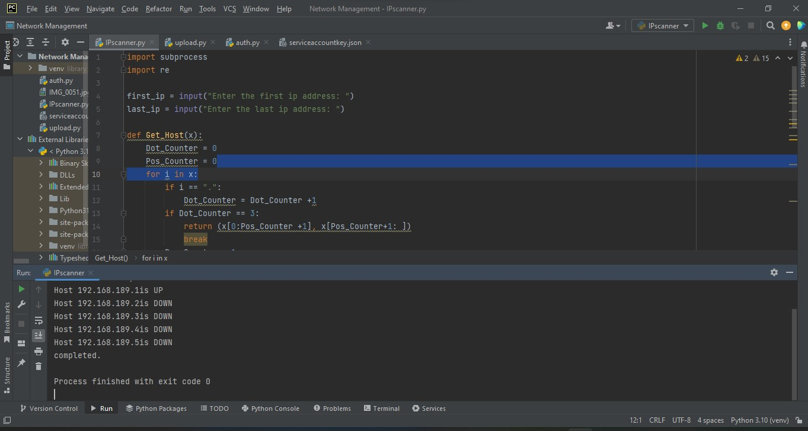

So this tool can monitor all the IP Address of the hosts that are connected to a particular network. And those are the things I could be able to do this interim . Then I will do my further works with the network devices’ location detecting tool that am going to implement and other tools before that.

**Initial project plan**

In my project, I should spend little bit more time to develop the network devices’ physical location detecting tool rather than hosts monitoring tool that I already created. So I have to do some research related to firebase with python. After creating that tool I will go through my next tool that is trouble shooting tool using python. Furthermore, I hope to create a tool to do configurations of network devices using python automation technologies.

**Time schedule of further works**

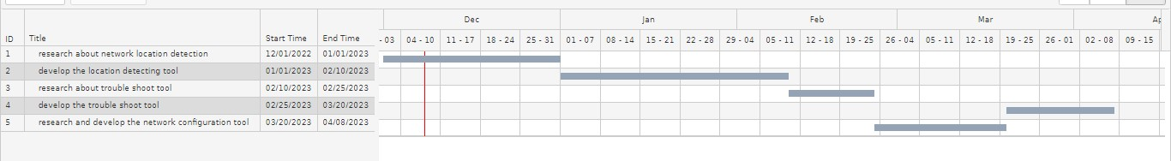

Tasks that are included above Gantt table-:

* research about network location detection.
* develop the location detecting tool.
* research about trouble shoot tool.
* develop the trouble shoot tool.

Furthermore developments-:

* research and develop the network configuration tool